USMLE Step 1 Web Prep — Central Nervous System
140125 >>> 0:00:00
SLIDE 1 of 33
INFECTIONS
ACUTE MENINGITIS
Acute aseptic (viral) meningitis
- Leptomeningeal inflammation
- Enterovirus
- Lymphocytic infliltrate
- Fever, meningeal irritation, decreased consciousness
- Low mortality

140130 >>> 0:00:51
SLIDE 2 of 33

ACUTE MENINGITIS CON’T  Acute purulent meningitis  - Purulent leptomeningeal inflammation- bacteria  - Neonates- E.coli, GBS  - Infants + children- H.Flu  - Adolescents + young adults- N. meningitidis  - Elderly- S.pneumoniae  - Diffuse cerebral edema  - Headache, fever + nuchal rigidity  - Cloudy sensorium coma death | 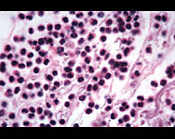

140135 >>> 0:02:07
SLIDE 3 of 33

ACUTE MENINGITIS CON’T
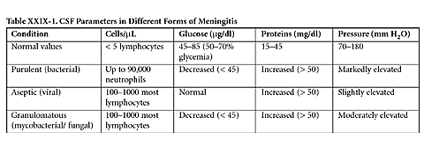

140140 >>> 0:03:05
SLIDE 4 of 33

VIRAL ENCEPHALIDITIES  Common features  - Perivascular cuffs  - Microglial nodules  - Neuron loss  Clinical  - Variable  Specific forms  - Herpes simplex type 1- hemorrhagic necrosis of temporal lobe  - Rabies- Negri bodies in hippocampal + Purkinje neurons  - PML- JC virus PML in immunocompromised  - Histopathology- demyelination | 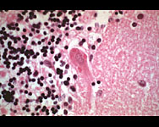

140145 >>> 0:04:53
SLIDE 5 of 33
FUNGAL MENINGOENCEPHALITIS
• Candida
• Aspergillus + mucor – tropism for vessels hemorrhage
• Mucor- diabetic patients, sinusitis encephalititis
• Aspergillus – immunocompromised

140150 >>> 0:05:31
SLIDE 6 of 33

TOXOPLASMOSIS  • AIDS patients  • Cerebral abscess  • CT- ring-enhancing lesion | 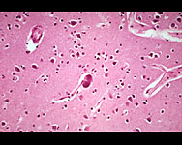

140155 >>> 0:05:49
SLIDE 7 of 33
CEREBRAL ABSCESS
• Hematogenous spread
• Endocarditis
• CT- ring-enhancing lesion
• Clinical- signs of increased intracranial pressure

140160 >>> 0:06:25
SLIDE 8 of 33
CREUTZFELDT-JACOB DISEASE
Caused by prior protein ( PrP)
- 30-kD protein in normal neurons
- Normal configuration – α helix
- In disease changes to β pleated sheet
- Hereditary
- Contagious- (corneal transplant, electrodes, growth hormone)

140165 >>> 0:08:40
SLIDE 9 of 33
CREUTZFELDT-JACOB DISEASE CON’T
Spongiform change
- Vacuolization of neuropil
- Kuru plaques
Clinical
- Sporadic- 85%
- Familial- 15%
- Middle-age + elderly
- Rapidly progressive dementia
- Death within 1 year

140170 >>> 0:09:52
SLIDE 10 of 33
CEREBROVASCULAR DISEASE
Epidemiology
- 3rd cause of death
- Risk factors similar to CAD
TIA
- Reversible
- Symptoms last < 24 hours
Stroke
- Stable neurological deficits
- 2 types
  - Infarction
  - Hemorrhage

140175 >>> 0:10:51
SLIDE 11 of 33
CEREBROVASCULAR DISEASE CON’T
Infarction
- Thrombotic
  - Atherosclerosis
  - Thrombosis of cerebral artery pale infarct
- Embolic
  - Cardiogenic
  - Hemorrhagic infarction

140180 >>> 0:12:09
SLIDE 12 of 33

CEREBROVASCULAR DISEASE CON’T
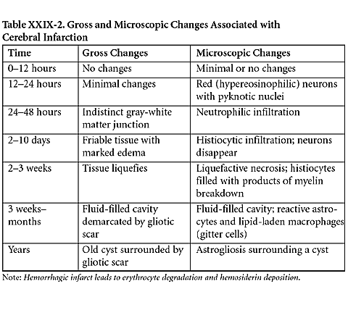

140185 >>> 0:13:27
SLIDE 13 of 33
CEREBROVASCULAR DISEASE CON’T
HEMORRHAGE (15% of strokes)
Epidural
- Traumatic- skull fracture
- Middle meningeal artery
- cerebral herniation
- Lucid interval before loss of consciousness

140190 >>> 0:14:37
SLIDE 14 of 33

HEMORRHAGE CON’T  Sudural  - Traumatic  - Bridging veins  - Headache, drowsiness, focal neurologic deficits  - Recurrent  Subarachnoid  - Ruptured berry aneurysm  - Sudden “worst headache of my life” | 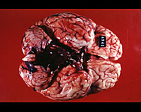

140195 >>> 0:15:42
SLIDE 15 of 33

HEMORRHAGE CON’T  Intracerebral hemorrhage  - Hypertension  - Basal ganglia + white matter  - Severe headache, nausea + vomiting  - LOC coma death  Berry aneurysm  - Most common cause of subarachnoid hemorrhage  - Branching points of anterior Circle of Willis Congenital focal arterial weakness  - Polycystic kidney disease, Ehlers-Danlos, + Marfan’s  - Sudden increase in BP rupture | 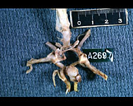

140200 >>> 0:16:55
SLIDE 16 of 33
DEMYELINATING DISORDERS
Multiple sclerosis
Definition
- Chronic relapsing- remitting disorder
- Probably autoimmune
- Recurrent episodes of demyelination progressive neurologic deficits
• Epidemiology
- 1/1000
- Women
- 3rd or 4th decade
- Familial propensity
- HLA- DR2

140205 >>> 0:17:55
SLIDE 17 of 33

MULTIPLE SCLEROSIS CON’T  Pathology  Gross  - plaques in white matter  - plaques are similar color to gray matter  Clinical  - Relapsing- remitting course- 85%  - Blurred vision, loss of vision + diplopia  - Loss of sensation/ weakness in leg  - Hemiparesis  Treatment  - Steroids  - Interferon-B | 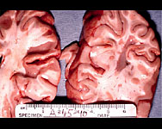

140210 >>> 0:20:08
SLIDE 18 of 33
DEGENERATIVE AND DEMENTING DISORDERS
3 main disorders
• Parkinson’s disease
• Huntington’s disease
• Alzheimer’s disease

140215 >>> 0:20:22
SLIDE 19 of 33
PARKINSON’S DISEASE
Definiton
- Loss of dopaminergic neurons in Substantia nigra
- Tremor rigidity + akinesia
Epidemiology
- 2% of population
- 5th – 8th decade

140220 >>> 0:20:52
SLIDE 20 of 33

PARKINSON’S DISEASE CON’T  Pathology  - Gross- pallor of SN  - Micro- loss of pigmented neurons in SN, Lewy bodies  Clinical  - Slowing of voluntary movements  - “pill-rolling” tremor  - Masked facies  - “cogwheel rigidity”  - Depression  Treatment  - Levodopa | 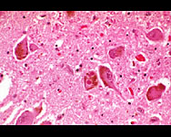

140225 >>> 0:21:51
SLIDE 21 of 33
HUNTINGTON’S DISEASE
Definition
- Autosomal dominant
- Degeneration of GABA-nergic neurons in caudate nucleus
Epidemiology
- Northwestern European descent
Etiopathogenesis
- HD gene- chromosome 4
- Mutations – expansion of unstable trinucleotide repeat
- Genomic imprinting + anticipation
Clinical
- 20-40 years of age
- Dementia
- Chorea
- Suicidal tendencies

140230 >>> 0:23:30
SLIDE 22 of 33

THE DEMENTIAS
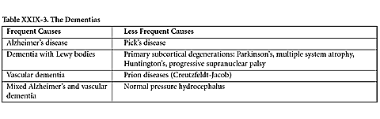

140235 >>> 0:23:41
SLIDE 23 of 33

Table XXIX-4. Genetics of AD  Mutations known to cause AD:  Amyloid precursor protein (APP) gene (chromosome 21)  Presenilin-1 gene (chromosome 14): majority of hereditary AD cases  Mutations of presenilin-2 gene (chromosome 1)  AD caused by all of the above mutations is early in onset.  Apolipoprotein E gene:  There are 3 allelelic forms of this gene, e2, e3, and e4.  The allele e4 of apolipoprotein E (ApoE) increases the risk for AD:  e4 allele is overrepresented in AD patients  e2 is underrepresented; it confers relative protection.  AD associated with e4 ApoE allele is late in onset.  Trisomy 21:  Virtually all Down patients are destined to develop AD in their forties.  Down patients have triple copies of the APP gene.  Epidemiology 60% of all dementias  - Risk factors- age, head trauma, + aluminum  - Protective factors- higher education  • Etiopathogenesis  - Genetic factors  - 5-10% | 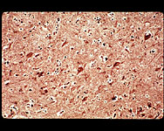

140240 >>> 0:25:16
SLIDE 24 of 33

ALZHEIMER’S DISEASE CON’T  Pathology  - Accumulation of abnormal proteins  - APP- Chromosome 21  - Abnormal tau-NFT  - Micro  - amyloid core  - neurotic/ dendritic processes  - Neurofibrillary tangles  • Affected areas- learning + memory  • Hippocampus + temporal lobe  • Gross  - Atrophic brains, esp. hippocampus + temporal lobes | 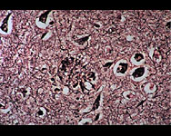

140245 >>> 0:27:23
SLIDE 25 of 33
ALZHEIMER’S DISEASE CON’T
Clinical
- 7th –8th decade
- Progressive memory loss- recent events
- Alterations in mood + behavior
- Aphasia
- Mute + bedridden
Treatment
- None

140250 >>> 0:28:01
SLIDE 26 of 33
CNS TUMORS
Epidemiology
- 50% metastatic, 50% primary
- Most common primary: glioblastoma multiforme ( GBM)
Clinical
- Headache
- Seizures
- Mental changes
- Focal neurologic deficits
- Symptoms related to increase intracranial pressure

140255 >>> 0:28:26
SLIDE 27 of 33
CNS TUMORS CON’T
Benign vs. Malignant
• Malignant
- Do not metastasize
- Invade adjacent structures

140260 >>> 0:28:45
SLIDE 28 of 33
Table XXIX-5. Differences Between Primary and Metastatic Tumors
Primary | Metastatic
Poorly circumscribed | Well circumscribed
Usually single | Often multiple
Location varies according to specific type | Usually located at the junction between  gray and white matter

140265 >>> 0:29:18
SLIDE 29 of 33

CNS TUMORS CON’T  Astocytoma  • Fibrillary background  • + GFAP  • Diffuse growth pattern  - Fibrillary astrocytoma  - Grading- Daumas-Duport 1-4  - Grade 4- Glioblastoma multiforme  - Most common primary  - Histo- nuclear atypia, mitosis, necrosis + VEH  - Pseudopalisading  - White matter  - Spread : corpus collosum “ butterfly” glioma  - Prognosis : poor | 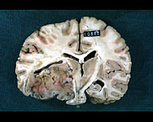

140270 >>> 0:31:31
SLIDE 30 of 33

CNS TUMORS CON’T  Oloigodendroglioma  • 30-50 years of age  • White matter  • Seizures  • Histo  - Perinuclear halo- “fried-egg”  - Chickenwire vascular pattern  • 5-10 year survival | 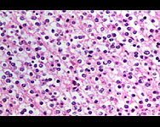

140275 >>> 0:32:24
SLIDE 31 of 33
CNS TUMORS CON’T
Meningioma
• Meningothelial cells of arachnoid
• Female adults
• Gross
- Attached to dura
• Micro
- Indistinct borders
- Whorls/fascicles
- Psammoma bodies
• Prognosis
- Good
• Treatment
- Complete surgical resection

140280 >>> 0:33:21
SLIDE 32 of 33
CNS TUMORS CON’T
Primitive neuroectodermal tumors
• Highly differentiated
• Medulloblastoma
• Kids
• Midline, cerebellum
• Histo
- Small round cells + pseudorosettes
• Highly aggressive
• Spreads thru CSF
• Resection + radiotherapy – 5 yr survival – 75%

140285 >>> 0:34:24
SLIDE 33 of 33
CNS TUMORS CON’T
Schwannoma
• Associated with Neurofibromatosis type 2
• Bilateral acoustic neuromas
Craniopharyngioma
• Originates from Rathke’s pouch
• Cystic- black fluid
• Histo- resembles teeth

