Water Quality Lab
Purpose:
- To perform water quality tests on local bodies of water and calculate the water quality index score and rating for the water body
- To analyze the water quality measurements and make inferences about the living organisms in the water body, effects of the natural environment to the water body, and the human impacts to the water body.
Procedure Overview:
- Test your water for the following components of the water quality index: pH, turbidity, total dissolved solids, dissolved oxygen, phosphate, and nitrate. Refer to the instructions at each station for the specific directions for running each test. Wash off the probes after use.
- Using the graphs given, determine the Q-value for each of the above measurements.
- Refer to the WQI calculation instructions and determine the WQI rating of your water.
- In order to further investigate any waste or detritus in your sample, perform an ammonia test (not included in the WQ index data) and a five-day BOD test.

Full Lab Report Directions:
Introduction, Materials, & Data/Results – as we’ve done previously
Note: This lab Word document including the Water Quality Index data table will be on my
website should you want to copy and paste the data table from my Word document.
Analysis Questions:
1. Based on your location, how can you explain your pH value? What can you infer about the water quality of your location based on the pH value?
2. Based on your location, how can you explain your turbidity measurement? What can you infer about the water quality of your location based on the turbidity?
3. Based on your location, how can you explain your total dissolved solids measurement? What can you infer about the water quality of your location based on the TDS?
4. Based on your location, how can you explain your dissolved oxygen measurement? What can you infer about the water quality of your location based on the DO?
5. How might the DO have changed in your sample since you retrieved the water?
5. Based on your location, how can you explain your phosphate measurement? What can you infer about the water quality of your location based on the amount of phosphate?
6. Based on your location, how can you explain your nitrate measurement? What can you infer about the water quality of your location based on the amount of nitrate?
Conclusion:
Same things to include as always, but remember you don’t need restate every bit of the results (as you have it in the data table & analysis questions). Summarize what is significant and focus on any test that indicated particularly good quality water or water that was likely impacted by humans.
Water Quality Index Data & Calculations Sheet
Date: Time of day:
Site name: ___________________________________________________________________________
Site description: _______________________________________________________________________
____________________________________________________________________________________

WQI Data Table
Test | Results | Unit | Q-Value | Weighting | Subtotal
 |  |  |  | factor
Temperature, ΔT |  | °C |  | 0.11
pH |  | pH unit |  | 0.11
Turbidity |  | NTU |  | 0.08
Total Dissolved Solids |  | mg/L or ppm |  | 0.07
Dissolved Oxygen |  | % sat. |  | 0.17
5-Day BOD |  | mg/L (ppm) |  | 0.11
Phosphate (PO₄-) |  | mg/L (ppm) |  | 0.10
Nitrates (NO₃–) |  | mg/L (ppm) |  | 0.10
Fecal Coliform |  | CFU/100 mL |  | 0.16

WQI Score
WQI Rating
WQI Calculation Procedure:
1. Record the test result for each test.
2. Using the given graphs for each test, determine and record the Q-value.
3. Multiply the Q-value by the weighting factor and record this as the subtotal for each test.
4. If all nine tests had been completed, we would add up the subtotals to get the score. We cannot tell the exact WQI without all nine, but we can approximate it with the six tests we performed.
To do so, add up the subtotals for all tests we did. Sum = _______________
Now add the weighting factors for the tests we performed. Sum = _______________
Divide our subtotal sum by the weighting factor sum. This is our WQI Score. Record above.
5. Use the score to find the WQI Rating from the table below.

Water Quality Index Ratings
91 –100 | Excellent
71 – 90 | Good
51 – 70 | Medium
26 – 50 | Poor
0 – 25 | Very Poor

Temperature
INTRODUCTION
The temperature of a body of water influences its overall quality. Water temperatures outside the “normal” range for a stream or river can cause harm to the aquatic organisms that live there. It is for this reason that the change in the temperature of the water over a section of a stream is measured, not just the temperature at one location. If the water temperature changes by even a few degrees over a one-mile stretch of the stream, it could indicate a source of thermal pollution.
Factors that Affect Water Temperature
- Air temperature
- Amount of shade
- Soil erosion increasing turbidity
- Thermal pollution from human activities
- Confluence of streams
Thermal pollution caused by human activities is one factor that can affect water temperature. Many industries use river water in their processes. The water is treated before it is returned to the river, but is warmer than it was before. Runoff entering a stream from parking lots and rooftops is often warmer than the stream and will increase its overall temperature.
Shade is very important to the health of a stream because of the warming influences of direct sunlight. Some human activities may remove shade trees from the area which will allow more sunlight to reach the water, causing the water temperature to rise.
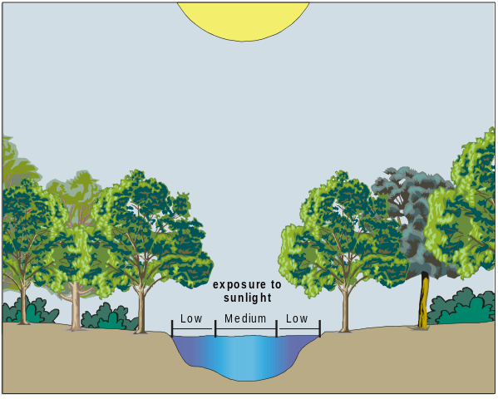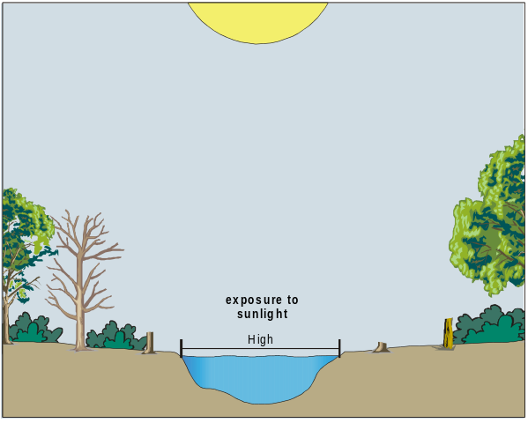
Another factor that may affect water temperature is the temperature of the air above the water. The extent of its influence has a great deal to do with the depth of the water. A shallow stream is more susceptible to changes in temperature than a deep river would be.
While many factors can contribute to the warming of surface water, few cause it to be cooled. One way water can be cooled is by cold air temperatures. A second, natural method of cooling a river or lake comes from the introduction of colder water from a tributary or a spring.
Effects of Water Temperature
- Solubility of dissolved oxygen
- Rate of plant growth
- Metabolic rate of organisms
- Resistance in organisms
Table 1: Optimal Temperature Ranges
Organism | Temperature Range (°C)
Trout | 5 – 20
Smallmouth bass | 5 – 28
Caddisfly larvae | 10 – 25
Mayfly larvae | 10 – 25
Stonefly larvae | 10 – 25
Water boatmen | 10 – 25
Carp | 10 – 25
Mosquito | 10 – 25
Catfish | 20 – 25
One important aspect of water temperature is its effect on the solubility of gases, such as oxygen. More gas can be dissolved in cold water than in warm water. Animals, such as salmon, that require a high level of dissolved oxygen will only thrive in cold water.
Increased water temperature can also cause an increase in the photosynthetic rate of aquatic plants and algae. This can lead to increased plant growth and algal blooms, which can be harmful to the local ecosystem.
A change in water temperature can affect the general health of the aquatic organisms, thus changing the quality of the stream. Table 1 lists the optimal temperature ranges of some selected aquatic organisms. When the water temperature becomes too hot or too cold, organisms become stressed, lowering their resistance to pollutants, diseases, and parasites.
Expected Levels
Water temperatures can range from 0°C in the winter to above 30°C in the summer. Cooler water in a stream is generally considered healthier than warmer water, but there are no definitive standards. Problems generally occur when changes in water temperature are noted along one stream on the same day. Some sample data are listed in Table 2.
Table 2: Water Temperatures of Selected Rivers
Site | Season | Temperature  (°C) | Season | Temperature  (°C)
Hudson River, Poughkeepsie, NY | Winter | 5 | Summer | 25
Missouri River, Garrison Dam, ND | Winter | 3 | Summer | 14
Rio Grande, El Paso, TX | Winter | 16 | Summer | 21
Mississippi River, Memphis, TN | Winter | 7 | Summer | 29
Willamette River, Portland, OR | Winter | 9 | Summer | 22
Method
The temperature data used for the Water Quality Index is the change in temperature along one stretch of a particular stream or river on a single day that is measured, generally one mile apart.
We are not doing this test as it would have required you to get to two locations and record the temperature yourself, as water samples would change temperatures by the time we measured them in school.
pH
INTRODUCTION
Water contains both hydrogen ions, H⁺, and hydroxide ions, OH–. The relative concentrations of these two ions determine the pH value. Water with a pH of 7 has equal concentrations of these two ions and is considered to be a neutral solution. If a solution is acidic, the concentration of H⁺ ions exceeds that of the OH– ions. In a basic solution, the concentration of OH– ions exceeds that of the H⁺ ions. On a pH scale of 0 to 14, a value of 0 is the most acidic, and 14 the most basic. A change from pH 7 to pH 8 in a lake or stream represents a ten-fold increase in the OH– ion concentration.
Table 1: Effects of pH Levels on Aquatic Life
pH | Effect
3.0 – 3.5 | Unlikely that fish can survive for more than a few hours in this range, although some plants and invertebrates can be found at pH levels this low.
3.5 – 4.0 | Known to be lethal to salmonids.
4.0 – 4.5 | All fish, most frogs, insects absent.
4.5 – 5.0 | Mayfly and many other insects absent. Most fish eggs will not hatch.
5.0 – 5.5 | Bottom-dwelling bacteria (decomposers) begin to die. Leaf litter and detritus begin to accumulate, locking up essential nutrients and interrupting chemical cycling. Plankton begin to disappear. Snails and clams absent. Mats of fungi begin to replace bacteria in the substrate.
 | Metals (aluminum, lead) normally trapped in sediments are released into the acidified water in forms toxic to aquatic life.
6.0 – 6.5 | Freshwater shrimp absent. Unlikely to be directly harmful to fish unless free carbon dioxide is high (in excess of 100 mg/L)
6.5 – 8.2 | Optimal for most organisms.
8.2 – 9.0 | Unlikely to be directly harmful to fish, but indirect effects occur at this level due to chemical changes in the water.
9.0 – 10.5 | Likely to be harmful to salmonids and perch if present for long periods.
10.5 – 11.0 | Rapidly lethal to salmonids. Prolonged exposure is lethal to carp, perch.
11.0 – 11.5 | Rapidly lethal to all species of fish.
Rainfall generally has a pH value between 5 and 6.5. It is acidic because of dissolved carbon dioxide and air pollutants, such as sulfur dioxide or nitrogen oxides. If the rainwater flows over soil containing hard-water minerals, its pH usually increases. Bicarbonate ions, HCO₃–, resulting from limestone deposits react with the water to produce OH– ions, according to the equation:
HCO₃– + H₂O → H₂CO₃ + OH–
As a result, streams and lakes are often basic, with pH values between 7 and 8, sometimes as high as 8.5.
The measure of the pH of a body of water is very important as an indication of water quality, because of the sensitivity of aquatic organisms to the pH of their environment. Small changes in pH can endanger many kinds of plants and animals; for example, trout and various kinds of nymphs can only survive in waters between pH 7 and pH 9. If the pH of the waters in which they live is outside of that range, they may not survive or reproduce.

Changes in pH can also be caused by algal blooms (more basic), industrial processes resulting in a release of bases or acids (raising or lowering pH), or the oxidation of sulfide-containing sediments (more acidic).
To gain a full understanding of the relationship between pH and water quality, you need to make measurements of the pH of a stream, as described in this test, and also determine the stream’s alkalinity, as described in Test 11 in this manual. Alkalinity is a measurement of the capacity or ability of the body of water to neutralize acids in the water. Acidic rainfall may have very little effect on the pH of a stream or lake if the region is rich in minerals that result in high alkalinity values. Higher concentrations of carbonate, bicarbonate, and hydroxide ions from limestone can provide a natural buffering capacity, capable of neutralizing many of the H⁺ ions from the acid. Other regions may have low concentrations of alkalinity ions to reduce the effects of acids in the rainfall. In the Northeastern United States and Eastern Canada, fish populations in some lakes have been significantly lowered due to the acidity of the water caused by acidic rainfall. If the water is very acidic, heavy metals may be released into the water and can accumulate on the gills of fish or cause deformities that reduce the likelihood of survival. In some cases, older fish will continue to live, but will be unable to reproduce because of the sensitivity of the reproductive portion of the growth cycle.
Factors that Affect pH Levels
- Acidic rainfall
- Algal blooms
- ll blooms in body of water
- Level of hard-water minerals
- Releases from industrial processes
- Carbonic acid from respiration or
decomposition
- Oxidation of sulfides in sediments
Expected Levels
The pH value of streams and lakes is usually between pH 7 and 8. Levels between 6.5 and 8.5 pH are acceptable for most drinking water standards. Areas with higher levels of water hardness (high concentrations of Mg²⁺, Ca²⁺, and HCO₃– ) often have water with higher pH values (between 7.5 and 8.5).
Method
We will use pH electrodes to determine the pH of our samples (kept in the refrigerator since sampling).
Turbidity
INTRODUCTION
Turbidity is a measure of water’s lack of clarity. Water with high turbidity is cloudy, while water with low turbidity is clear. The cloudiness is produced by light reflecting off of particles in the water; therefore, the more particles in the water, the higher the turbidity.
Sources of Turbidity
- Soil erosion
- silt
- clay
- Urban runoff
- road grime
- rooftops
- parking lots
- Industrial waste
- sewage treatment effluent
- particulates
- Abundant bottom-dwellers
- stirring up sediments
- Organics
- microorganisms
- decaying plants and animals
- gasoline or oil from roads

Many factors can contribute to the turbidity of water.
An increase in stream flow due to heavy rains or a decrease in stream-bank vegetation can speed up the process of soil erosion. This will add suspended particles, such as clay and silt, to the water.
Runoff of various types contains suspended solids that may add to the turbidity of a stream. Agricultural runoff often contains suspended soil particles. Other types of runoff include industrial wastes, water treatment plant effluent, and urban runoff from parking lots, roads, and rooftops.
Bottom-dwelling aquatic organisms, such as catfish, can contribute to the turbidity of the water by stirring up the sediment that has built up on the bottom of the stream. Organic matter such as plankton or decaying plant and animal matter that is suspended in the water can also increase the turbidity in a stream.
Effects of Turbidity
- Reduces water clarity
- Aesthetically displeasing
- Decreases photosynthetic rate
- Increases water temperature
High turbidity will decrease the amount of sunlight able to penetrate the water, thereby decreasing the photosynthetic rate. Reduced clarity also makes the water less aesthetically pleasing. While this may not be harmful directly, it is certainly undesirable for many water uses.
When the water is cloudy, sunlight will warm it more efficiently. This occurs because the suspended particles in the water absorb the sunlight, warming the surrounding water. This can lead to other problems associated with increased temperature levels.
While highly turbid water can be detrimental to an aquatic ecosystem, it is not correct to assume that clear water is always healthy. Slightly turbid water can be perfectly healthy, while clear water could contain unseen toxins or unhealthy levels of nutrients.

Expected Levels
Turbidity is measured in Nephelometric Turbidity Units, NTU. According to the USGS, the turbidity of surface water is usually between 1 NTU and 50 NTU. Turbidity is often higher than this, however, especially after heavy rain when water levels are high. Turbidity can be lower than expected in still water because of the settling of suspended particles that might occur. The turbidity of some selected rivers are shown in Table 1. Water is visibly turbid at levels above 5 NTU. The standard for drinking water is 0.5 NTU to 1.0 NTU.
Table 1: Turbidity Levels in Selected Rivers
Site | Turbidity (NTU)
Sacramento River, Keswick, CA | 4
Hudson River, Poughkeepsie, NY | 15
Mississippi River, Memphis, TN | 39
Rio Grande, El Paso, TX | 80
Colorado River, CO-UT state line | 180
Sacramento River, Keswick, CA | 4

Method
Turbidity will be measured using a Vernier Turbidity Sensor. You will calibrate the turbidity sensor and then insert a cuvette of your water sample in the Turbidity Sensor and read the turbidity value in NTU read directly from the computer.
Total Dissolved Solids
INTRODUCTION
Solids are found in streams in two forms, suspended and dissolved. Suspended solids include silt, stirred-up bottom sediment, decaying plant matter, or sewage-treatment effluent. Suspended solids will not pass through a filter, whereas dissolved solids will. Dissolved solids in freshwater samples include soluble salts that yield ions such as sodium (Na⁺), calcium (Ca²⁺), magnesium (Mg²⁺), bicarbonate (HCO₃–), sulfate (SO₄^{2–} ), or chloride (Cl– ). Total dissolved solids, or TDS, can be determined by evaporating a pre-filtered sample to dryness, and then finding the mass of the dry residue per liter of sample. A second method uses a Vernier Conductivity Probe to determine the ability of the dissolved salts and their resulting ions in an unfiltered sample to conduct an electrical current. The conductivity is then converted to TDS. Either of these methods yields a TDS value in units of mg/L.
Sources of Total Dissolved Solids
- Hard-Water Ions
- Ca²⁺
- Mg²⁺
- HCO₃–
- Fertilizer in agricultural runoff
- NH₄⁺
- NO₃–
- PO₄^{3–}
- SO₄^{2–}
- Urban runoff
- Na⁺
- Cl–
- Salinity from tidal mixing, minerals, or
returned irrigation water
- Na⁺
- K⁺
- Cl–
- Acidic rainfall
- H⁺
- NO₃–
- SO₃^{2–}, SO₄^{2–}
The TDS concentration in a body of water is affected by many different factors. A high concentration of dissolved ions is not, by itself, an indication that a stream is polluted or unhealthy. It is normal for streams to dissolve and accumulate fairly high concentrations of ions from the minerals in the rocks and soils over which they flow. If these deposits contain salts (sodium chloride or potassium chloride) or limestone (calcium carbonate), then significant concentrations of Na⁺, K⁺, Cl– will result, as well as hard-water ions, such as Ca²⁺ and HCO₃– from limestone.
TDS is sometimes used as a “watchdog” environmental test. Any change in the ionic composition between testing sites in a stream can quickly be detected using a Conductivity Probe. TDS values will change when ions are introduced to water from salts, acids, bases, hard-water minerals, or soluble gases that ionize in solution. However, the tests described here will not tell you the specific ion responsible for the increase or decrease in TDS. They simply give a general indication of the level of dissolved solids in the stream or lake. Further tests described in this book can then help to determine the specific ion or ions that contributed to changes in the initial TDS reading.
There are many possible manmade sources of ions that may contribute to elevated TDS readings. Fertilizers from fields and lawns can add a variety of ions to a stream. Increases in TDS can also result from runoff from roads that have been salted in the winter. Organic matter from wastewater treatment plants may contribute higher levels of nitrate or phosphate ions. Treated wastewater may also have higher TDS readings than surrounding streams if urban drinking water has been highly chlorinated. Irrigation water that is returned to a stream will often have higher concentrations of sodium or chloride ions. Acidic rainwater, with dissolved gases like CO₂, NO₂, or SO₂, often yields elevated H⁺ ion concentrations.
If TDS levels are high, especially due to dissolved salts, many forms of aquatic life are affected. The salts act to dehydrate the skin of animals. High concentrations of dissolved solids can add a laxative effect to water or cause the water to have an unpleasant mineral taste. It is also possible for dissolved ions to affect the pH of a body of water, which in turn may influence the health of aquatic species. If high TDS readings are due to hard-water ions, then soaps may be less effective, or significant boiler plating may occur in heating pipes.
Expected Levels
TDS values in lakes and streams are typically found to be in the range of 50 to 250 mg/L. In areas of especially hard water or high salinity, TDS values may be as high as 500 mg/L. Drinking water will tend to be 25 to 500 mg/L TDS. United States Drinking Water Standards include a recommendation that TDS in drinking water should not exceed 500 mg/L TDS. Fresh distilled water, by comparison, will usually have a conductivity of 0.5 to 1.5 mg/L TDS.
Table 1: TDS in Selected Rivers
Site | Season | TDS  (mg/L) | Season | TDS  (mg/L)
Rio Grande River, El Paso, TX | Spring | 510 | Fall | 610
Mississippi River, Memphis, TN | Spring | 133 | Fall | 220
Sacramento River, Keswick, CA | Spring | 71 | Fall | 60
Ohio River, Benwood, WV | Spring | 300 | Fall | 143
Hudson River, Poughkeepsie, NY | Spring | 90 | Fall | 119
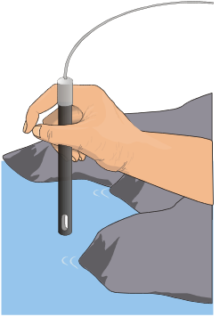
Method
A Vernier Conductivity Probe will be used to measure TDS of the solution. After calibration, the value will be read directly off the computer screen.

Dissolved Oxygen
INTRODUCTION
Oxygen gas dissolved in water is vital to the existence of most aquatic organisms. Oxygen is a key component in cellular respiration for both aquatic and terrestrial life. The concentration of dissolved oxygen, DO, in an aquatic environment is an important indicator of the environment’s water quality.
Table 1: Minimum DO Requirements
Organism | Minimum dissolved oxygen (mg/L)
Trout | 6.5
Smallmouth bass | 6.5
Caddisfly larvae | 4.0
Mayfly larvae | 4.0
Catfish | 2.5
Carp | 2.0
Mosquito larvae | 1.0
Some organisms, such as salmon, mayflies, and trout, require high concentrations of dissolved oxygen. Other organisms, such as catfish, mosquito larvae, and carp, can survive in environments with lower concentrations of dissolved oxygen. The diversity of organisms is greatest at higher DO concentrations. Table 1 lists the minimum dissolved oxygen concentrations necessary to sustain selected animals.
Oxygen gas is dissolved in water by a variety of processes—diffusion between the atmosphere and water at its surface, aeration as water flows over rocks and other debris, churning of water by waves and wind, and photosynthesis of aquatic plants. There are many factors that affect the concentration of dissolved oxygen in an aquatic environment. These factors include: temperature, stream flow, air pressure, aquatic plants, decaying organic matter, and human activities.
Sources of DO
- Diffusion from atmosphere
- Aeration as water moves over rocks and debris
- Aeration from wind and waves
- Photosynthesis of aquatic plants
As a result of plant activity, DO levels may fluctuate during the day, rising throughout the morning and reaching a peak in the afternoon. At night photosynthesis ceases, but plants and animals continue to respire, causing a decrease in DO levels. Because large daily fluctuations are possible, DO tests should be performed at the same time each day. Large fluctuations in dissolved oxygen levels over a short period of time may be the result of an algal bloom. While the algae population is growing at a fast rate, dissolved oxygen levels increase. Soon the algae begin to die and are decomposed by aerobic bacteria, which use up the oxygen. As a greater number of algae die, the oxygen requirement of the aerobic decomposers increases, resulting in a sharp drop in dissolved oxygen levels. Following an algal bloom, oxygen levels can be so low that fish and other aquatic organisms suffocate and die.
Factors that affect DO levels
- Temperature
- Aquatic plant populations
- Decaying organic material in water
- Stream flow
- Altitude/atmospheric pressure
- Human activities
Temperature is important to the ability of oxygen to dissolve, because oxygen, like all gases, has different solubilities at different temperatures. Cooler waters have a greater capacity for dissolved oxygen than warmer waters. Human activities, such as the removal of foliage along a stream or the release of warm water used in industrial processes, can cause an increase in water temperature along a given stretch of the stream. This results in a lower dissolved oxygen capacity for the stream.
Expected Levels
When relating DO measurements to minimum levels required by aquatic organisms, mg/L is used. The unit mg/L is the quantity of oxygen gas dissolved in one liter of water and is equal to the unit ppm (parts per million). Dissolved oxygen concentrations can range from 0 to 15 mg/L. Cold mountain streams will likely have DO readings from 7 to 15 mg/L, depending on the water temperature and air pressure. In their lower reaches, rivers and streams can have DO readings between 2 and 11 mg/L. Hypoxic waters, like those in a dead zone, have readings at 2 mg/L or below.
Table 2
DO Level | Percent Saturation of DO
Supersaturation | ≥ 101%
Excellent | 90 – 100%
Adequate | 80 – 89%
Acceptable | 60 – 79%
Poor | < 60%
When discussing the DO in a stream or river we also use the “percent saturation” for water quality comparisons. As discussed on the front, temperature greatly affects the amount of oxygen that water can hold. Therefore, the same mg/L reading can reflect a different percent saturation in two water samples of different temperatures. The manner in which percent saturation relates to water quality is displayed in Table 2. (In some cases, water can exceed 100% saturation and become supersaturated for short periods of time. Supersaturation can be harmful to aquatic organisms by causing disease known as Gas Bubble Disease).
Method
Dissolved oxygen can be measured accurately directly at the site. Transporting samples is generally not recommended because it reduces the accuracy of test results, even when capped and free of air bubbles. However, we did not have a choice with your samples so we will take the DO readings in lab, knowing there may be some sources of error affecting the accuracy of the result. Think about the sources and factors affecting DO, as listed on the front, to hypothesize how your water sample may have changed between the collection to measurement times.
We will take the DO readings using a ThermoFisher Scientific Rough Dissolved Oxygen Probe (a fairly new, advanced technology for taking DO measurements).
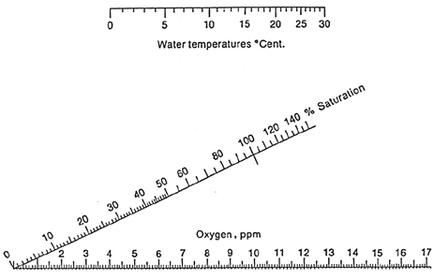
When you take the DO reading, take the temperature of the water as well (°C).
Then use the oxygen saturation chart on the left to determine the percent saturation of your water. Connect a line between your water temperature and DO reading. The point where the line crosses the percent saturation line gives you the value.

Biochemical Oxygen Demand
INTRODUCTION
Oxygen available to aquatic organisms is found in the form of dissolved oxygen. Oxygen gas is dissolved in a stream through aeration, diffusion from the atmosphere, and photosynthesis of aquatic plants and algae. Plants and animals in the stream consume oxygen in order to produce energy through respiration. In a healthy stream, oxygen is replenished faster than it is used by aquatic organisms. In some streams, aerobic bacteria decompose such a large volume of organic material that oxygen is depleted from the stream faster than it can be replaced. The resulting decrease in dissolved oxygen is known as the Biochemical Oxygen Demand (BOD).
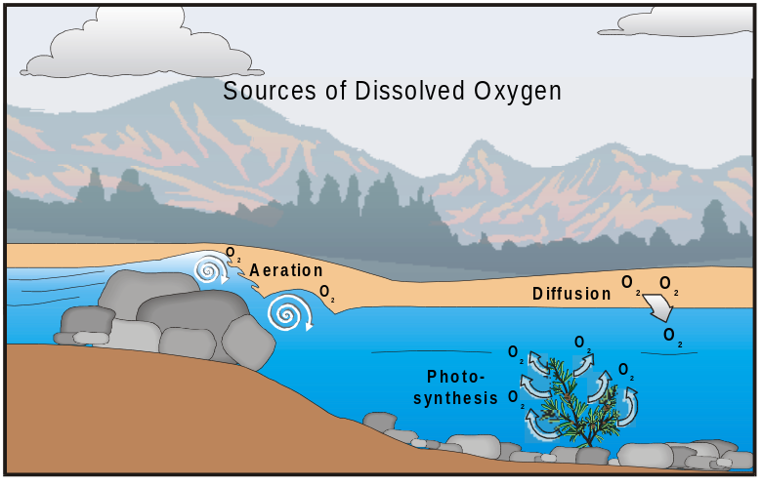
When it rains, organic material found in the soil is transported in the rainwater to streams and rivers. Additional organic material accumulates in the stream when aquatic organisms die. Bacteria and other microorganisms decompose this organic material. In a healthy body of water, this process has only a slight impact on dissolved oxygen levels. It serves to release vital nutrients, such as nitrates and phosphates, which stimulate algae and aquatic plant growth. If the amount of decomposing organic material is too high, dissolved oxygen levels can be severely reduced. In a body of water with large amounts of decaying organic material the dissolved oxygen levels may drop by 90%—this would represent a high BOD. In a mountain stream with low levels of decaying organic material, the dissolved oxygen levels may drop by only 10% or 20%—a low BOD.
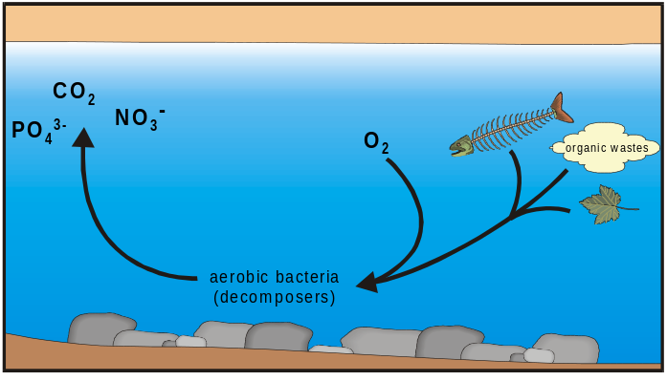
Organic materials, such as leaves, fallen trees, fish carcasses, and animal waste, end up in the water naturally and are important in the recycling of nutrients throughout the ecosystem. Organic materials that enter the water as a result of human impact can be considered sources of pollution.
Expected Levels
BOD levels are dependent on the body of water being tested. Shallow, slow-moving waters, such as ponds and wetlands, will often have large amounts of organic material in the water and high BOD levels. A water sample from a pond could have an initial dissolved oxygen reading of 9.5 mg/L. After the five-day incubation period, the dissolved oxygen could be down to 1 mg/L resulting in a high BOD level of 8.5 mg/L. In contrast, a water sample collected from a cold mountain stream with an initial dissolved oxygen reading of 11 mg/L may have decreased to 9 mg/L after incubation, resulting in a BOD of only 2 mg/L. Use Table 1 as a rough guide for the data you gather.
Table 1: Interpretation of BOD Levels
BOD Level (mg/L) | Status
1 – 2 mg/L | Clean water with little organic waster.
3 – 5 mg/L | Moderately clean water with some organic waste.
6 – 9 mg/L | Lots of organic material and many bacteria.
>10 mg/L | Very poor water quality. Large amounts of organic material in the water.

Method
We will not be performing this test today and using it to calculate the WQI today, but read below for how we can complete it over the next five days.
BOD is calculated from two separate dissolved oxygen measurements. The initial dissolved oxygen reading is taken at the sampling site using the DO methods. A sample is transported back to the lab and incubated at 20°C for a total of five days. After five days, the incubated sample is tested for dissolved oxygen. The oxygen reading at the end of the five days is subtracted from the initial reading. The resulting value is the BOD level.

Phosphates
(ortho- and total)
INTRODUCTION
Phosphorus is an essential nutrient for all aquatic plants and algae. Only a very small amount is needed, however, so an excess of phosphorus can easily occur. Excess phosphorus is usually considered to be a pollutant because it can lead to eutrophication—a condition where an overabundance of nutrients, such as phosphorus, causes increased plant and algal growth. Eutrophication can lower the levels of dissolved oxygen in the water and can render the water uninhabitable by many aquatic organisms. Phosphorus is often the limiting factor that determines the level of eutrophication that occurs.
Effects of Phosphate Levels
- High levels
- eutrophication
- increased algal blooms
- increased BOD
- decreased DO
- Low levels
- limiting factor in plant and algal growth
Most phosphorus in surface water is present in the form of phosphates. There are four classifications of phosphates often referred to in environmental literature:
- orthophosphates are the inorganic forms of phosphate, such as PO₄^{3–}, HPO₄^{2–}, and H₂PO₄–. These are the forms of phosphates used heavily in fertilizers and are often introduced to surface waters through runoff.
- organically bound phosphates are found in human and animal wastes or in decaying organic matter.
- condensed phosphates (also called polyphosphates), such as P₃O₁₀^{5–}, are sometimes added to water supplies and industrial processes to prevent the formation of scaling and to inhibit corrosion. This is the form of phosphate that was commonly found in detergents in the past.
- total phosphates are the sum of all three of the forms described above. This is the most commonly reported form of phosphate concentration.
Phosphates are added to surface waters by a variety of means. Humans add phosphates to water through industrial and agricultural wastes. Fertilizers contain high levels of phosphates and will enter the water by means of runoff and soil erosion. In areas where land and vegetation have been disturbed, soil erosion will increase. This will lead to even more phosphates being washed out of the soil and into the water. Phosphates can also come from the excrement of animals living in or near the water.
Sources of Phosphates
- Human and animal wastes
- Industrial wastes
- Agricultural runoff
- Human disturbance of land
Expected Levels
The concentration of phosphates will be expressed throughout this test in units of mg/L PO₄-P, meaning phosphorus in the form of phosphates. Levels above 0.1 mg/L PO₄-P can stimulate plant growth above its natural rate. Water that receives runoff from heavily fertilized areas may have higher levels of phosphates.
A study by the U.S. Geological
Survey, based on 410 sites throughout the United States, reports that in 1982, approximately 55% of the sites reported phosphate levels of greater than 0.1 mg/L PO₄-P. By 1989, this percentage had dropped to close to 40%. This decline is due in part to the reduction of phosphorus content in detergents and fertilizers.
Table 1: Phosphate Levels of Selected Rivers
Site | Total Phosphates (mg/L PO₄-P) | Ortho-phosphates (mg/L PO₄-P)
Missouri River, St. Joseph, MO | 0.64 | 0.11
Hudson River, Poughkeepsie, NY | 1.60 | 0.02
Missouri River, Garrison Dam, ND | 0.02 | 0.01
Rio Grande, El Paso, TX | 0.41 | 0.07
Willamette River, Portland, OR | 0.09 | 0.06
Method
Orthophosphates are relatively easy to measure and will usually give a rough indication of the total level of phosphates in the water. Orthophosphate concentration is determined by means of a chemical reaction resulting in a color change dependent on the concentration of orthophosphates present.
We will use a portable phosphate Hach test kit with color wheel to calculate the amount of phosphates in our water.
NOTE: This test takes about ten minutes to complete!
Nitrate
INTRODUCTIOn
The tests described here are used to measure the concentration of nitrate ions, NO₃–, in a water sample. The concentration of nitrate will be expressed throughout this section in units of mg/L NO₃–-N. The unit, NO₃–-N, means simply “nitrogen that is in the form of nitrate.”
Nitrate ions found in freshwater samples result from a variety of natural and manmade sources. Nitrates are an important source of nitrogen necessary for plants and animals to synthesize amino acids and proteins. Most nitrogen on earth is found in the atmosphere in the form of nitrogen gas, N₂. Through a process called the nitrogen cycle, nitrogen gas is changed into forms that are useable by plants and animals. These conversions include industrial production of fertilizers, as well as natural processes, such as legume-plant nitrogen fixation, plant and animal decomposition, and animal waste.
Sources of Nitrate Ions
- Agriculture runoff
- Urban runoff
- Animal feedlots and barnyards
- Municipal and industrial wastewater
- Automobile and industrial emissions
- Decomposition of plants and animals
Although nitrate levels in freshwater are usually less than 1 mg/L, manmade sources of nitrate may elevate levels above 3 mg/L. These sources include animal feedlots, runoff from fertilized fields, or treated municipal wastewater being returned to streams. Levels above 10 mg/L in drinking water can cause a potentially fatal disease in infants called methemoglobinemia, or Blue-Baby Syndrome. In this disease, nitrate converts hemoglobin into a form that can no longer transport oxygen.
High nitrate concentrations also contribute to a condition in lakes and ponds called eutrophication, the excessive growth of aquatic plants and algae. Unpleasant odor and taste of water, as well as reduced clarity, often accompany this process. Eventually, dead biomass accumulates in the bottom of the lake, where it decays and compounds the problem by recycling nutrients. If other necessary nutrients are present, algal blooms can occur in a lake with as little as 0.50 mg/L NO₃–-N.
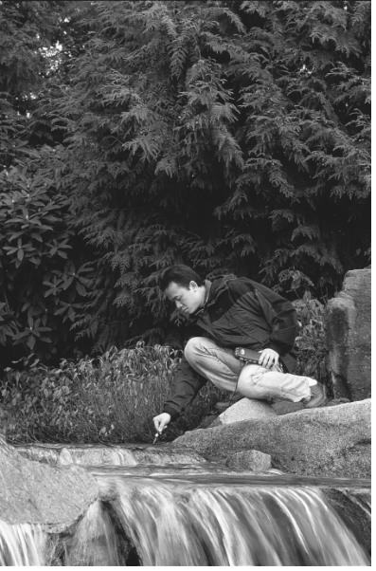
Nitrate pollution of surface and groundwater has become a major ecological problem in some agricultural areas. Although fertilizer in runoff is most often blamed, there is evidence that concentration of livestock in feedlots is now the major source of agricultural nitrate pollution. Runoff from fertilized fields is still a significant source of nitrate, although fertilizer use peaked in 1981 and has remained fairly constant since.
Expected Levels
The nitrate level in freshwater is usually found in the range of 0.1 to 4 mg/L NO₃–-N. Unpolluted waters generally have nitrate levels below 1 mg/L. The effluent of some sewage treatment plants may have levels in excess of 20 mg/L.
In a study based on 344 USGS sites throughout the United States, 80% of the sites reported nitrate levels less than 1 mg/L, 16% were in the range of 1 – 3 mg/L, and 4% were greater than 3 mg/L. The percentage of various land types reporting greater than 1 mg/L of nitrate were
range land <5%, forested land ~10%, urban areas ~30%, and agricultural land ~40%.
Table 1: Nitrate Concentration in Selected Sites
Site | Nitrate  spring level  (mg/L NO₃–-N) | Nitrate  fall level  (mg/L NO₃–-N)
Mississippi River, Clinton, IA | 0.55 | 1.20
Mississippi River, Memphis, TN | 1.60 | 2.90
Rio Grande River, El Paso, TX | 0.38 | 0.59
Ohio River, Benwood, WV | 0.87 | 1.30
Willamette River, Portland, OR | 0.28 | 0.98
Missouri River, Garrison Dam, ND | 0.40 | 0.14
Hudson River, Poughkeepsie, NY | 0.49 | 0.64
Platte River, Sharpes Station, MO | 1.90 | 1.30

Method
We will use a portable Hach nitrate test kit with color wheel to calculate the amount of nitrates in our water.
NOTE: This test takes about fifteen minutes to complete!
Fecal Coliform
INTRODUCTION
The concentration of fecal coliform bacteria in water is measured to determine the likelihood of contamination by microbiological organisms. While fecal coliform are not pathogenic (disease causing), they are commonly found alongside pathogenic organisms such as those responsible for dysentery, gastroenteritis, and hepatitis A. It is easier to test for fecal coliform than for pathogenic organisms; therefore, the presence of fecal coliform in a water sample is used to indicate potential contamination. A common source of coliforms and pathogenic bacteria is raw sewage. Fecal coliform bacteria occur naturally in the digestive tract of warm-blooded animals, where they aid in the digestion of food.
Sources of Raw Sewage
- Urban stormwater runoff containing domestic animal waste
- Agricultural sources such as dairies and cattle
- Sewage treatment overflow
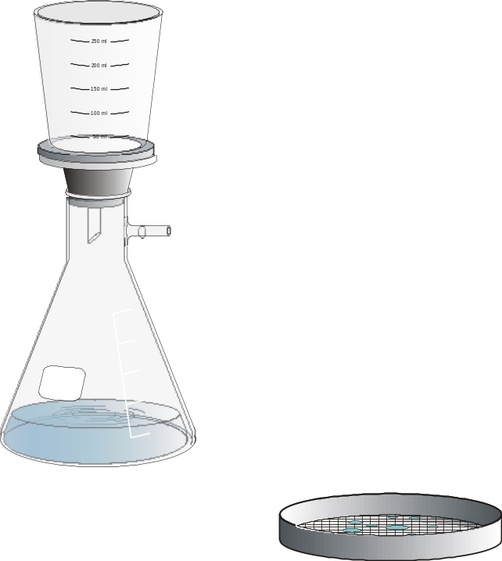The results of coliform bacteria tests are generally used to monitor recreational areas, stormwater out-falls, and drinking water supplies. Water is commonly tested for three types of coliform bacteria: fecal coliforms, total coliforms, and E. coli. The standards for drinking water are generally based on total coliforms. The accepted standard for drinking water is that there should be no coliforms present after the water is filtered or treated. Natural waters will nearly always contain some form of bacteria. That is why you should never drink untreated water from a river or lake. Currently, the most common measurement for surface waters is fecal coliform. In some areas, standards for surface water contamination are shifting to the measurement of E. coli.
Expected Levels
Standards for fecal coliform differ from state to state. For specific requirements, it is best to contact your state or regional health department. Standards for fecal coliform are considerably more strict if the water is used for total body contact such as swimming, rather than used only for boating with minimal direct contact.
When interpreting data from fecal coliform tests, it is important to remember that there can be a high degree of randomness of distribution within a sample. A large number of data points are necessary to obtain statistically significant data. Fecal coliform is measured in colony forming units per 100 mL, CFU/100 mL, of water tested.
Table 1
Water use | Desired level (CFU/100mL) | Permissible level (CFU/100mL)
Drinking | 0 | 0
Swimming | <200 | <1,000
boating or fishing | <1,000 | <5,000

Method
We will not be performing this test.
In order to complete this test, you would attempt to grow and then count bacteria colonies from your seawater.
The water sample is filtered through sterile 47 mm filters. The filters are placed in petri dishes containing nutrient-rich broth and incubated for a period of 24 hours at 44.5°C. Following incubation, the petri dishes are removed from the incubator and each dish is counted for fecal coliform colonies.

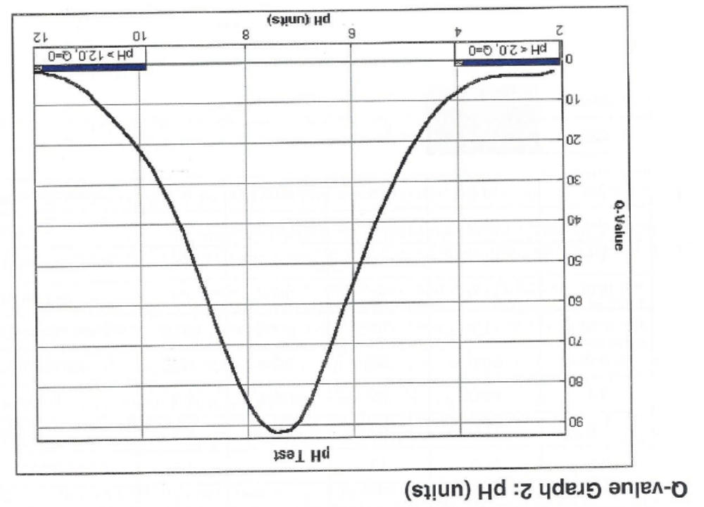

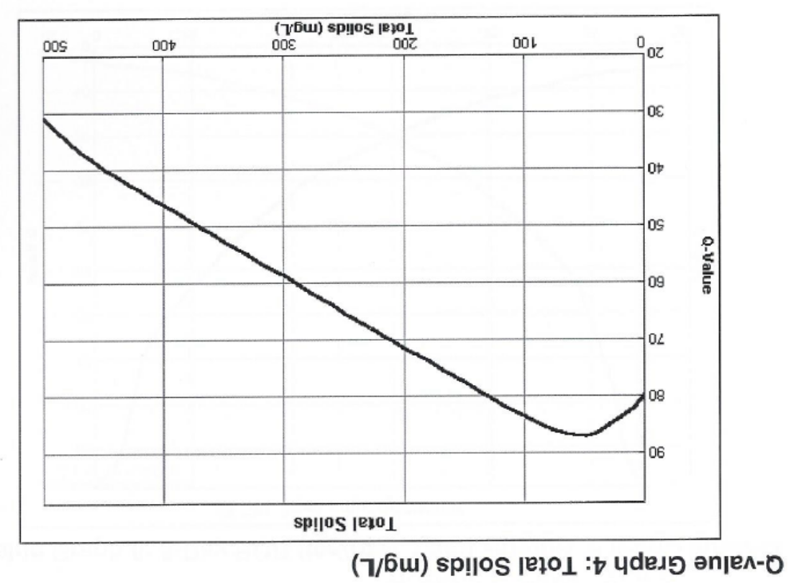

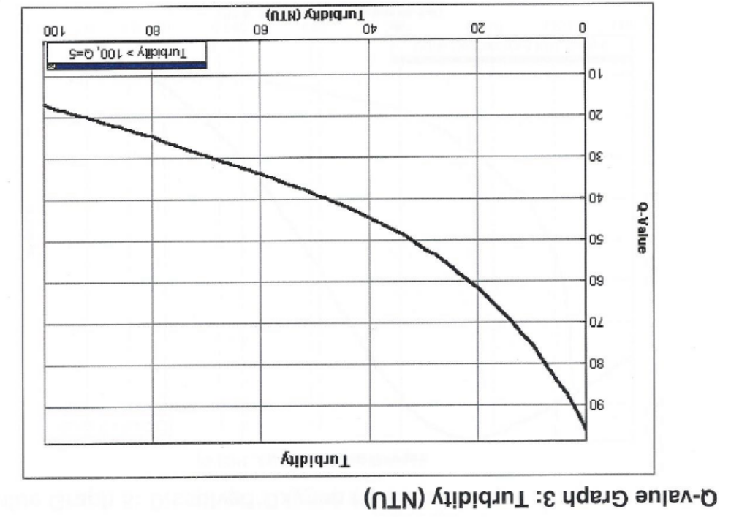

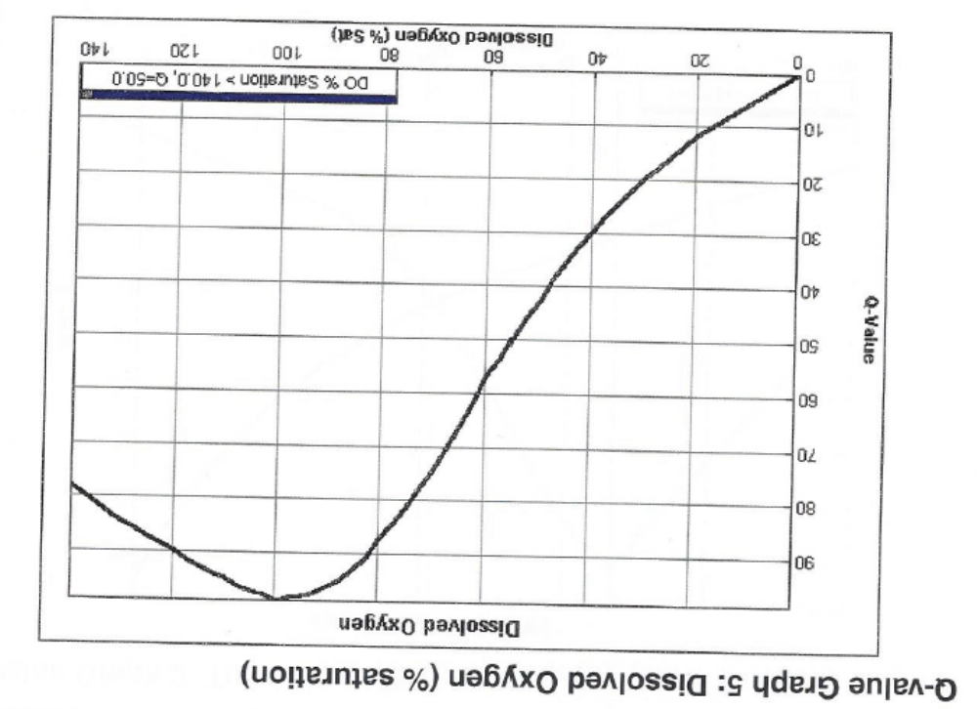

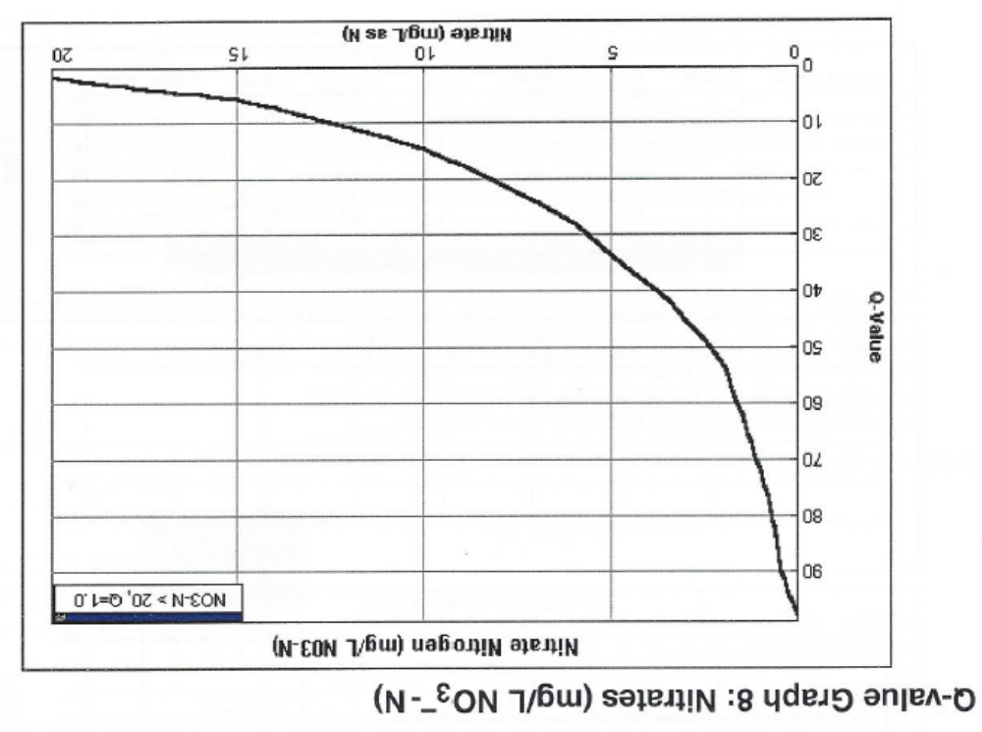
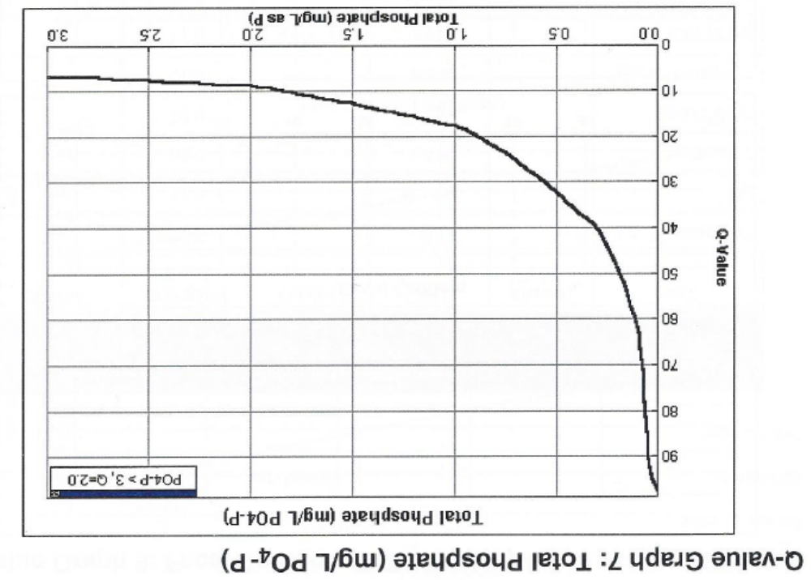

The pH value is calculated as the negative log of the hydrogen ion concentration: pH = –log [H⁺].
Established by 1986 Amendments to the Safe Drinking Water Act
Note that no charge is given to the PO4 when it is used in reporting phosphate units. Here it is being used as a generic symbol for many forms of phosphates with varying charges, such as PO43– and HPO42–.
U.S. Geological Survey, National Water Summary 1990–91, Hydrologic Events and Stream Water Quality, Water-Supply Paper 2400, United States Government Printing Office, 1993, 124–125.
See Test 10: Ammonium Nitrogen, p. 10-1, for further information on the nitrogen cycle.
U.S. Geological Survey, National Water Summary 1990–91, Hydrologic Events and Stream Water Quality, Water-Supply Paper 2400, United States Government Printing Office, 1993, 122–123.
CFU values in this chart were obtained from the LaMotte Company’s “The Monitor Handbook.” These values are meant to be used as guidelines. Consult your local or state health department or your regional USEPA or USGS office for specific values for your region.

